**Ex No:06 PL/SQL**

**Aim:**

To work with PL/SQL

**Procedure:**

Step1: Open Run SQL on Command line and connect to SQL .

Step 2: Then work with database using PL/SQL Block commands

1. Declare
2. Begin
3. Exception
4. End

**SYNTAX:**

DECLARE

<declarations section>

BEGIN

<executable section commands>

EXCEPTION

<exception handling>

END;

**EXAMPLE:**

**1.Addition of Two Numbers:**

**Program Code:**

SQL> SET SERVEROUTPUT ON;

SQL> declare

2 x number(5);

3 y number(5);

4 z number(5);

5 begin

6 x:=50;

7 y:=20;

8 z:=x+y;

9 dbms_output.put_line('sum is'||z);

10 end;

11 /

**Output:**

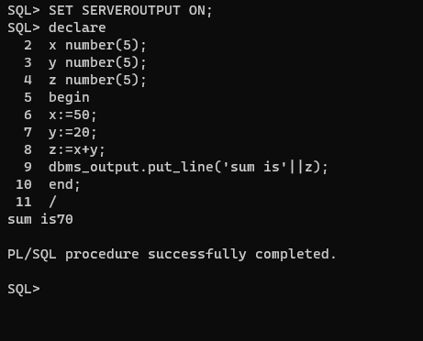

**2.Generating Series:**

**Program Code:**

SQL> SET SERVEROUTPUT ON;

SQL> declare

2 n number(5);

3 begin

4 n:=1;

5 for i in 1..10 loop

6 case n

7 when 1 then

8 dbms_output.put_line(i);

9 when 2 then

10 if mod(i,2)=0 then

11 dbms_output.put_line(i);

12 end if;

13 when 3 then

14 if mod(i,2)!=0 then

15 dbms_output.put_line(i);

16 end if;

17 end case;

18 end loop;

19 end;

20 /

**OUTPUT:**

